

AEROWORLD:

A reflective and Visual Portfolio

# Project Overview

## Project background

Aéroworld, a French company with a strong international focus, was founded fifty years ago. Today, it is a global leader in the aerospace industry, with thousands of employees spread across many countries.

Aéroworld focuses on several key areas, such as the design, development, manufacturing, and maintenance of aircraft. The company is known for its diverse range of products, from commercial and transport aircraft to helicopters.

## Stakes & challenges

Aéroworld faces major challenges in managing vast and diverse data generated from flight tests, sensors, operations, and customer sources. The company must implement secure, scalable infrastructure and advanced analytics (AI/ML) to collect, store, and analyze data effectively—while ensuring interoperability across systems and strong data protection to drive innovation and flight safety.

**Aéroworld is seeking data analytics talent showing a reflective approach and strong analytical abilities aligned with the company’s objectives. Potential candidates must showcase their business and technical abilities with the creation of a reflective and visual portfolio.**

## Smart objectives

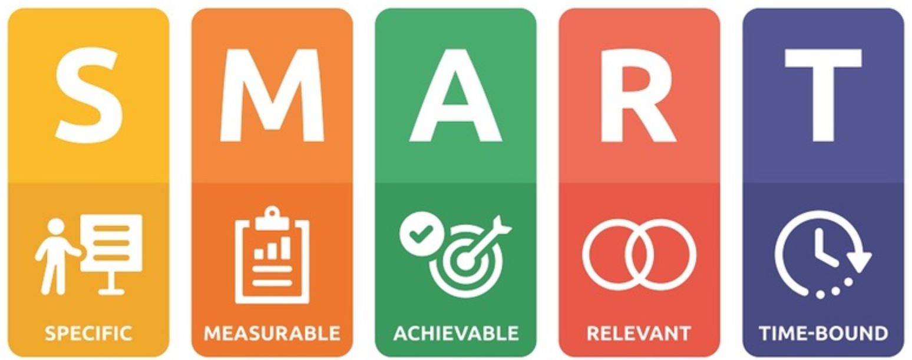

### Main Objective

**Apply to Aéroworld’s data analyst opening by submitting a project portfolio in the form of an interactive dashboard.**

* Specific: Create a detailed and visually engaging digital portfolio that highlights the candidate’s skills in data analysis, project management, technology watch, and consulting mindset.
* Measurable: The portfolio will include at least 3 complete projects, each with a clear problem statement, methodology, tools used, results, and reflections
* Attainable: All content will be developed using existing skills and learning resources, with regular milestones.
* Relevant: This portfolio is essential to demonstrate professional capabilities to recruiters in data-related roles.
* Time-based: The full portfolio will be completed and published online within 6 weeks.

### Secondary Objectives

**1. Illustrate technical capabilities (tools, programming languages, modeling, data visualization)**

* Specific: Showcase at least 3 projects using different tools like Python, PowerBI, or KNIME
* Measurable: Each project will include code samples, dashboards, and explanatory notes.
* Attainable: Use past work or learning projects to populate the portfolio.
* Relevant: Demonstrating technical proficiency is key for data analyst and consulting roles.
* Time-based: All technical project pages will be completed within 4 weeks.

2. **Provide a clear, concise, and visually appealing oral presentation version:**

* Specific: Create a 15-minute oral pitch using Power BI to walk through the key highlights of the portfolio with embedded visuals and interactivity.
* Measurable: Presentation rehearsed at least 3 times with peer feedback to ensure clarity and timing.
* Attainable: Build the interactive presentation entirely within Power BI using storytelling best practices.
* Relevant: Interactive dashboards in Power BI are highly valued in data-related interviews and project showcases.
* Time-based: Ready within 2 weeks after the full portfolio is complete.

# Requirements

## Functional requirements

**1. Industry & Tech Watch**

**User Story:***As a data analyst, I want to view curated content on new tools, techniques, and analysis methods so that I can stay up-to-date with industry best practices and continuously improve my skills.*

**Acceptance Criteria:**

* Content is categorized by tool, method, or trend.

**2. Business Needs Identification**

**User Story:***As a data analyst, I want to provide a structured summary of business constraints and objectives so that I can clearly understand the context and purpose of the data project.*

**Acceptance Criteria:**

* Each project entry links to its business goals, KPIs and constraints

**3. Functional Specification**

**User Story:***As a data analyst, I want to provide functional requirements and proposed solutions so that the project scope is clearly defined and aligned with stakeholder expectations.*

**Acceptance Criteria:**

* Each entry includes User story, main concern, main KPI description, main data used, and main formula.

**4. Project Organization**

**User Story:***As a data analyst, I want to plan and track the phases, milestones, and tasks of a data analysis project so that I can monitor progress and coordinate team efforts effectively.*

**Acceptance Criteria:**

* Visual timeline (e.g., Gantt or progress bar) shows project phases, tasks, deadlines and progress.

**5. Tool Adoption Support**

**User Story:***As a data analyst, I want to deliver simple guides and interactive help directly in the dashboard so that end-users can use the tools confidently without external support.*

**Acceptance Criteria:**

* Quick start guide or short video tutorials are accessible.

**6. Process Documentation**

**User Story:***As a data analyst, I want to write documentation on data sources, methodology, and processing steps so that I can ensure the analysis is transparent and auditable.*

**Acceptance Criteria:**

* Documentation is exportable as a PDF or report.

**7. Consulting Posture**

**User Story:***As a data analyst, I want to showcase my ability for consulting posture so that I can challenge initial assumptions and explore alternative solutions with confidence.*

**Acceptance Criteria:**

* Strategic prompts (e.g., “What if?”, “Why not?”, “Have you considered…?”) are visible in key decision areas.
* Recommendations or insights are clearly stated.

## Design requirements

**1. Ergonomics principles (or How easy and clear the interface is to use)**

* Clarity & Simplicity  
  Use a clean layout with minimal visuals and consistent color contrast to ensure readability.
* Consistency  
  Maintain uniform chart types, labels, and formatting across all pages.
* Information Hierarchy  
  Present key insights first; use font size and position to guide attention.
* Responsive Layout  
  Ensure visuals don’t overlap and adjust well to different screen sizes.
* Context & Documentation  
  Use tooltips and labels to clarify metrics, axes, and data sources.

**2. UX Design principles (or How the user experiences the product as a whole in terms of flow, emotions and usability)**

* Structured Navigation  
  Add buttons or menus for easy access to different dashboard sections.
* User Onboarding  
  Include a welcome screen or brief guide on how to use the dashboard.
* Interactive Filters  
  Allow users to filter by time, tools, or project to personalize insights.
* Visual Feedback  
  Use hover effects and highlights to indicate clickable or active elements.
* Accessibility  
  Apply color-blind-friendly palettes and check for screen reader compatibility.
* Mobile & Sharing  
  Optimize for mobile and ensure smooth sharing via link or embed.

## Technical requirements

Focusing on the 2 leaders of analytics solution, as ranked by Gartner

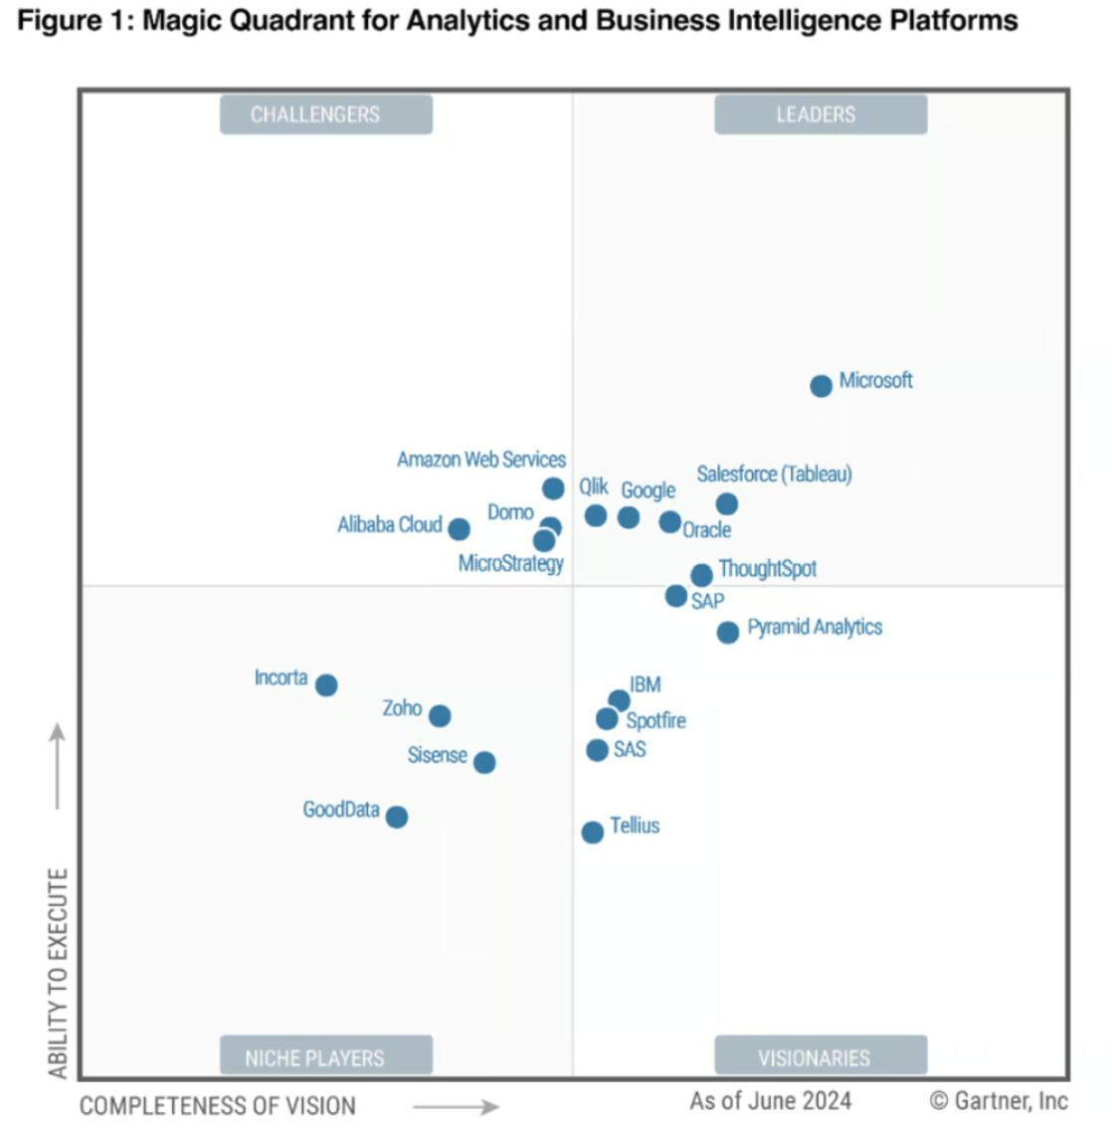

As the 2 tools are similar in functionalities, the suggestion is to go with PowerBI as the cheapest, as stated with this DataCamp comparison.

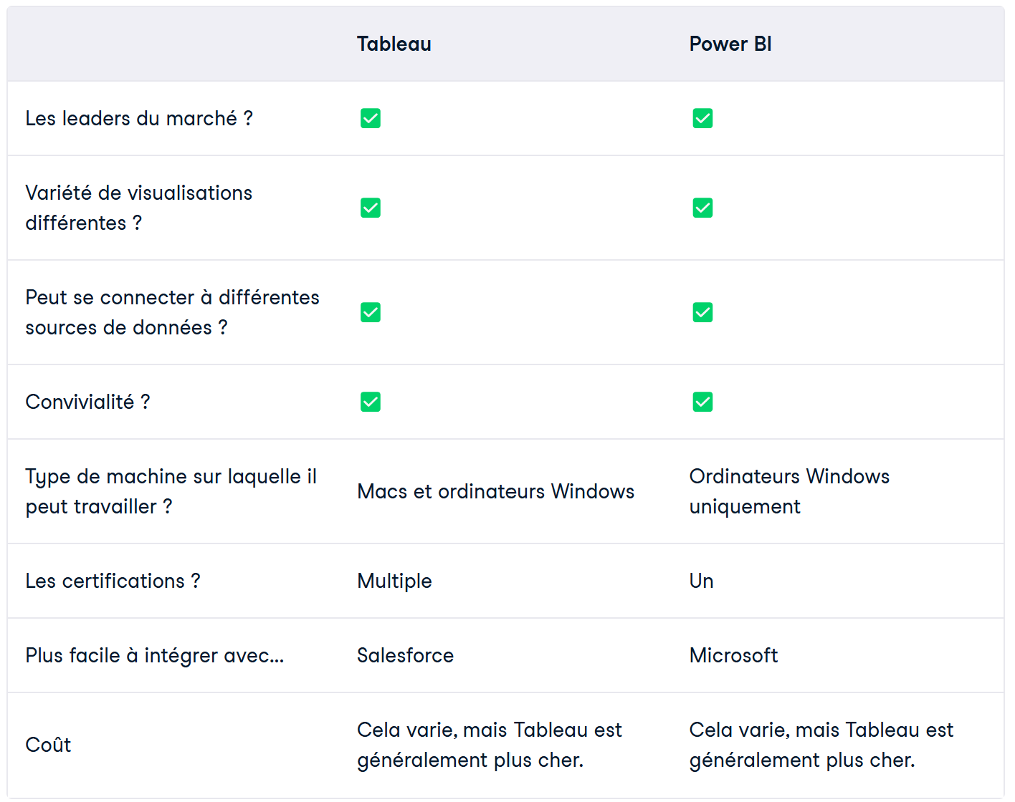

## Reglementary constraints

With no specific constraints, best is to always comply

* With reglementary constraints as GDPR

Ensure that any personal data collected is **anonymized** or **pseudonymized** when possible.

Implement **data access controls** to restrict unauthorized access, and provide users with clear options for **data consent** and the ability to request data deletion.

Ensure transparency about data usage through **privacy notices**.

* With quality standards as OPQUAST, W3C

Ensure **accessibility** (e.g., color contrast, keyboard navigation, and screen reader support) following **WCAG 2.1** guidelines.

Prioritize **clear navigation**, **mobile responsiveness**, and **cross-browser compatibility** to guarantee usability and inclusivity for all users.

# 

# 3. Project team

A data analyst who has different set of skills

* Business analyst during project setup to collect, analyze and define business requirements
* Data analyst during data preparation, modeling and evaluation phases to gather, understand, clean, prepare, aggregate and modelize data
* Data engineer for dashboard industrialization dor deployment phase
* Training analyst to provide materials for end-users like training video and operating model

# 4. Project plan & cost estimate

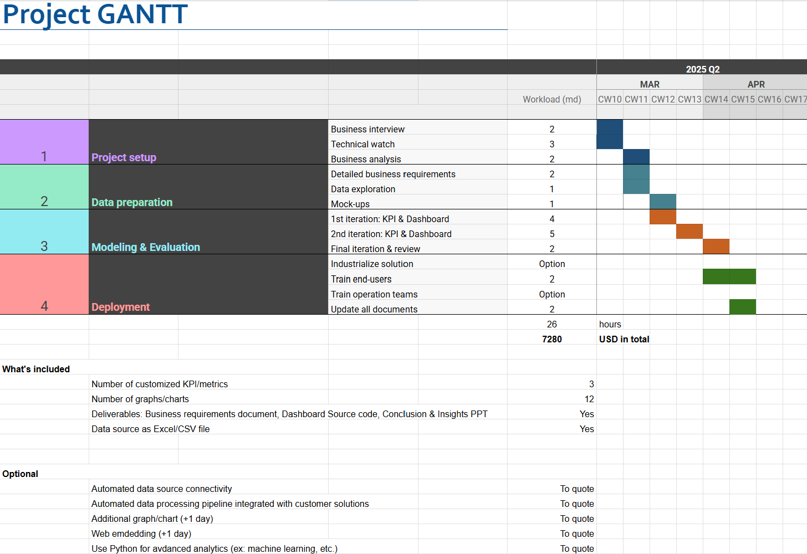

# 

# 5. Quality & performance

On Time, On Budget, On Scope (OTOBOS) KPI are critical project management metrics used to assess the overall performance and delivery success.

* Are we executing according to the planned schedule (On Time)?
  + No delay on key milestones. Tasks completed on agreed deadlines.
* Are we executing the allocated financial resources (On Budget)?
  + No extra expenses like adding resources to complete tasks on agreed deadlines, or like buying extra technical resources.
* Are we fulfilling all agreed deliverables and quality standards (On Scope)?
  + No reduction of scope, in terms of deliverables or features that was agreed during project setup.